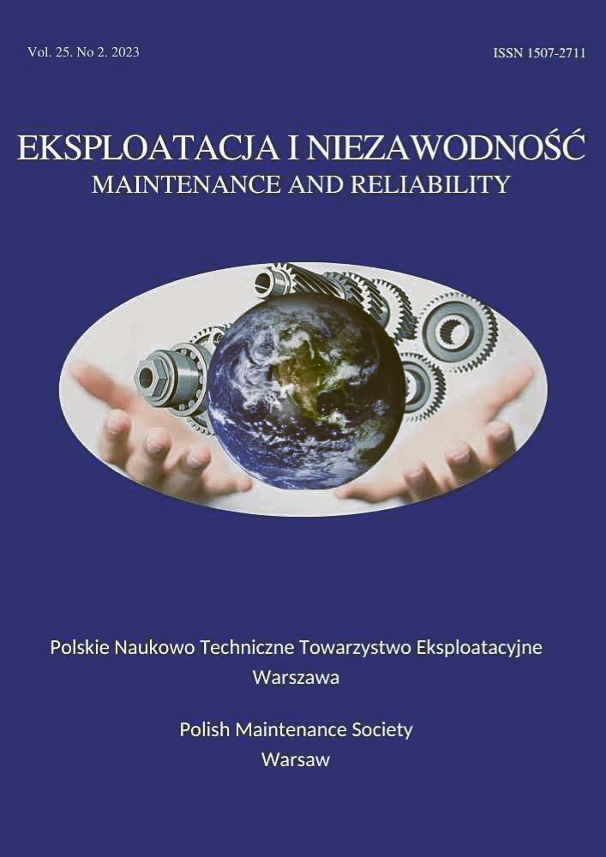 | Eksploatacja i Niezawodnosc – Maintenance and Reliability
 | Volume 28 (2026), Issue 3
journal homepage: http://www.ein.org.pl

Article citation info:
Gao X, Zhu B, Dong E, Cheng Z, Gao T, Wen L, Jiang K, Degraded system performance warranty decision model based on optimal preventive inspection, Eksploatacja i Niezawodnosc – Maintenance and Reliability 2026: 28(3) http://doi.org/ 10.17531/ein/218672
Degraded system performance warranty decision model based on optimal preventive inspection |  |  |  | Indexed by:

Xinjian Gaoª, Bo Zhuª, Enzhi Dongª, Zhonghua Cheng^{a,*}, Tielu Gaoª, Liang Wenª, Kexin Jiang^{b}

ª Shijiazhuang Campus of Army Engineering University of PLA, China
^{b} Shijiazhuang Flying College of PLAAF, China
Highlights |  | Abstract
- Proposed a performance warranty strategy with availability as the core.  - Designed a profit function that includes reward and punishment measures.  - A model was constructed with the goal of maximizing the manufacturer's warranty profit.  - Extended the interval between initial preventive inspection and avoided overinspection.  - Derived the degradation function of the Inverse Gaussian process. |  | To address the lack of research on condition-based maintenance optimization and incentive mechanisms within the performance warranty framework, this study focuses on a repairable system governed by an Inverse Gaussian degradation process. By integrating preventive inspection measures and an availability-centered reward-penalty mechanism, a novel performance warranty decision model is constructed. The model takes the initial inspection interval, subsequent inspection intervals, and preventive maintenance threshold as decision variables, with the objective of maximizing the manufacturer's warranty profit. A particle swarm optimization algorithm is employed to solve the model, followed by a case study. Experimental results demonstrate that compared to cost-minimization warranty strategy and non-differentiated periodic inspection strategy, the proposed performance warranty strategy achieves 7.9% and 21.5% improvements in manufacturer warranty profits, respectively, validating its effectiveness. Further sensitivity analysis increases the applicability of performance warranty strategy.
 |  |  | Keywords
This is an open access article under the CC BY license  (https://creativecommons.org/licenses/by/4.0/) |  |  | preventive maintenance, particle swarm optimization, condition-based maintenance, performance warranty strategy, Inverse Gaussian, preventive inspection

Introduction

(*) Corresponding author.  E-mail addresses: | X. Gao, 13912453267@163.com, B. Zhu, z12175320923@163.com, E. Dong, ez_dong@aeu.edu.cn, Z. Cheng, a15032073178@sina.com, T. Gao, gaotielu2002@163.com, L. Wen, lwenmark123@163.com, K. Jiang,  21938390@qq.com
In the face of the intense market competition, manufacturing enterprises generally consider product warranty a key component of their after-sales service systems. Warranty services not only provide consumers with post-purchase rights protection and reduce economic losses from product quality issues but also reflect the manufacturer's confidence in product reliability. Research indicates that a reasonable warranty strategy can significantly enhance a product's market competitiveness and positively impact the manufacturer's profits [1].
For high-reliability products with long-term usage characteristics, performance degradation is often a gradual process. Taking the power batteries of new energy vehicles as an example, although such batteries have a long service life, they inevitably experience capacity decay during charge-discharge cycles, manifesting as reduced driving range, increased energy consumption, and higher charging frequency. To address this issue, manufacturers have introduced the performance warranty strategy (PWS), which centers on transforming traditional warranty services into commitments regarding product performance outcomes [2]. PWS overcomes the limitations of conventional warranty models by shifting the focus from mere repair services to maintaining actual operational performance. Under PWS, users only need to set clear minimum performance thresholds and incentive mechanisms, without imposing rigid requirements on the manufacturer's specific maintenance methods. This flexibility encourages manufacturers to proactively optimize product quality, enhance maintenance efficiency, and refine service strategies, thereby fostering a mutually beneficial cycle for both supply and demand sides. PWS has been successfully applied in various fields, including new-energy vehicle powertrains, aviation equipment, and photovoltaic power generation systems [3].
Due to the scarcity of failure data for high-reliability products, traditional reliability assessment methods based on failure time are often inadequate. In this context, condition-based maintenance (CBM) strategies have emerged as a novel solution for maintaining such products. The feasibility of CBM strategies stems from breakthrough advancements in modern sensing and IoT technologies, which enable real-time monitoring and analysis of system operational parameters, thereby achieving precise maintenance timing [4]. Practical evidence demonstrates that CBM strategies can significantly improve equipment utilization efficiency, ensure system reliability, and effectively reduce maintenance costs. This advantage has led to their widespread adoption in industrial applications, with continuous expansion into new scenarios [5]. However, existing research has paid little attention to the synergistic optimization between CBM strategies and PWS mechanisms. Addressing this gap, this study innovatively integrates CBM strategies with PWS mechanisms to optimize CBM solutions within the PWS framework. The objective is to enhance system availability and increase manufacturer profitability.

Literature review
The academic community has made significant progress in performance warranty policy research, establishing a relatively comprehensive research framework. This section will systematically review existing achievements from two dimensions: theoretical research on performance warranties and decision-making modeling for performance warranties.

2.1. Theoretical research on performance warranties
Theoretical research on performance warranties primarily focuses on four key areas: the conceptual definition of performance warranties, the design of performance warranty contracts, the evaluation of their effectiveness, and the analysis of influencing factors. These research directions collectively form the comprehensive framework of performance warranty theory, with logical relationships illustrated in Figure 1.
Figure 1. Framework for performance warranty strategy research.
Clarifying the concept of performance warranty is fundamental to advancing the implementation of this strategy. Its importance lies in helping practitioners gain an in-depth understanding of the essential characteristics of performance warranties, thereby facilitating the effective execution of this strategy. In this framework, performance indicators serve as quantitative tools for assessing service quality and effectiveness, providing objective evaluation criteria for the service quality of warranty providers [6]. Hypko et al. focused on the manufacturing sector, defining the specific connotation of performance warranties and identifying three key issues overlooked in existing research [7]. Additionally, Randall et al. conducted comparative studies and found that the theoretical framework of performance warranties aligns closely with service-dominant logic, both of which emphasize the critical roles of organizational collaboration, leadership relationships, information systems, and environmental factors [8].
Performance warranty contracts serve as the core instrument for ensuring service effectiveness. Regarding domain-specific applications, Tan developed an analytical model of performance contracts in energy efficiency, examining the mechanisms by which energy-saving risks affect both suppliers and customers [9]. Addressing the challenge of quantifying performance contributions, Akkermans et al. proposed methodologies for defining, monitoring, and incentivizing performance metrics, effectively mitigating contractual execution limitations [10]. Selviaridis and Valk focused specifically on how incentive mechanisms influence supplier behavior and client relationships [11]. Additionally, Batista et al. systematically analyzed characteristic elements of performance contracts, providing theoretical guidance for military and industrial applications [12].
Research on the evaluation of performance warranty effectiveness aims to systematically identify the strengths and limitations of this strategy, providing a basis for informed decision-making by users. Based on actual data from aircraft engine manufacturers, researchers like Guajardo et al. conducted a comparative analysis of product reliability under time-and-materials contracts versus performance warranty contracts [13]. Hypko et al., working within the principal-agent theory framework, conducted an in-depth exploration of the benefits and risks associated with performance warranty contracts in manufacturing [14]. Their research demonstrated that, compared to traditional sales warranty models, performance warranty mechanisms are more effective in incentivizing manufacturers to expand their customer base and enhance profitability through technological innovation.
Research on influencing factors of performance warranties employs empirical case studies to systematically identify critical implementation elements, providing theoretical foundations for optimizing warranty strategies. From
a decision-making perspective, Schaefers et al. applied means-end chain theory to verify decision-makers' personal willingness as a critical implementation factor [15]. At the corporate practice level, Korkeamäki et al. investigated how R&D investment moderates economies of scale [16]. Additionally, Shang et al. constructed a credit risk assessment model using rough set theory to analyze Chinese energy enterprises, identifying credit deficiency as a major implementation barrier exacerbated by information asymmetry [17]. These multidimensional studies collectively advance the theoretical foundation for refining PWS, offering comprehensive insights into their optimization and practical application.

2.2. Research on performance warranty decision modeling
In the field of performance warranty decision modeling research, scholars have also conducted extensive explorations. For specialized application scenarios, Dai et al. divided the warranty period into replacement and repair zones and developed
a performance-degradation model that accounts for imperfect repairs to maximize overall profitability [18]. Yang et al. introduced a two-stage preventive maintenance (PM) strategy incorporating imperfect repairs and deferred replacements, based on the delay-time model [19]. Wang et al. studied competing failure modes in single-component systems, considering the combined effects of natural degradation and random shocks [20]. Li et al. constructed a condition-oriented maintenance model for shipborne antennas and established
a multi-dimensional evaluation framework [21]. In the domain of maintenance strategy optimization, Hosseinifard et al. focused on dynamic inventory optimization for suppliers [22]. Patra et al. established single and multi-period supplier performance warranty models that maximize supplier profits [23].
Although significant progress has been made in PWS research, several pressing gaps remain. First, existing research has mainly focused on developing theoretical frameworks, with a lack of specific warranty decision-making methods to support practical applications, thereby seriously restricting the implementation of PWS [24]. Second, the few studies that have used optimization to model warranty decisions have primarily adopted a regular maintenance model based on fixed-interval inspections [25], whereas research on differentiated settings for the initial inspection interval and subsequent intervals is relatively scarce. Given the characteristics of the early stages of system degradation, where the probability of exceeding the PM threshold is low, setting a longer initial inspection interval can reduce inspection frequency, thereby lower warranty costs, and reduce downtime, thereby increasing equipment availability. Finally, existing literature has not paid sufficient attention to the design of incentive and penalty mechanisms in performance warranties. By constructing a profit function that includes incentive and penalty measures, manufacturers can be effectively guided to focus on warranty performance, thereby achieving profit improvement.

Problem description
The degradation process of equipment status has significant stochastic characteristics. Describing its uncertainty using stochastic process theory is an effective method. Commonly used stochastic degradation processes include the Wiener, Gamma, Gaussian, and Inverse Gaussian (IG) distributions. Among them, the Wiener and Gaussian distributions are more suitable for describing non-monotonic degradation paths, while the Gamma and IG distributions are better suited for monotonic degradation paths. Compared with the Gamma distribution, the IG distribution has a more rigorous mathematical foundation when describing first-passage-time problems, such as the first failure time of equipment. The IG distribution is often used in the study of equipment life and reliability and can effectively model and analyze product failure times. This paper focuses on a repairable degradation system whose cumulative degradation process has non-negative increments and is strictly monotonically increasing. Therefore, the IG distribution is selected to describe the system's degradation process.
This study employs a method that combines the CBM strategy with a performance warranty. The PWS is implemented under the constraints of the contract signed between the manufacturer and the user. The manufacturer is required to conduct preventive inspections and carry out corresponding PM and corrective maintenance (CM) activities during the warranty period. The research aims to determine the optimal initial inspection interval, subsequent inspection intervals, and PM threshold to maximize the manufacturer's performance warranty profit. The relevant notations and fundamental assumptions are shown in Table 1.
(1) The system's condition inspection is non-destructive and very quick, during which the system's performance degradation is negligible.
(2) When the system's condition $L(t)<h_{p}$ is satisfied, the system will continue to operate until the next inspection.
(3) When the system's condition $h_{p}<L(t)<h_{f}$ reaches the PM threshold, PM will be implemented. The maintenance effect is described using a (p, q) model, where p represents the probability of the system being restored to "as good as new", and "q=1-p" represents the probability of the system remaining in its current state.
(4) When the system's condition$L(t)>h_{f}$reaches the failure threshold, a failure will occur and the CM will be implemented, which can fully restore the system to "as good as new".
(5) System failures have a hidden characteristic and can only be identified and confirmed through inspection.
Table 1. The relevant notations and basic assumptions.
W | Performance warranty period
$$h_{p}$$ | PM threshold
$$h_{f}$$ | Failure threshold
$$L(t)$$ | Degradation path of equipment condition over time
C_{p} | Cost of a single PM
C_{c} | Cost of a single CM
T_{p} | Time required for a single PM
T_{c} | Time required for a single CM
C_{j} | Cost of a single inspection
T_{j} | Time required for a single inspectio
D₁ | Initial inspection interval
D | Subsequent inspection interval
D_{max} | Time limit for inspection interval
T_{work} | Operating time of equipment within the warranty period
T_{halt} | Downtime of equipment within the warranty period
E_{p,k}(T_{halt}) | Expected downtime due to PM at the k-th inspection
E_{c,k}(T_{halt}) | Expected downtime due to CM at the k-th inspection
E_{p,k}(C) | Warranty cost due to PM at the k-th inspection
E_{c,k}(C) | Warranty cost due to CM at the k-th inspection
E(T_{halt}) | Downtime of equipment
EC | Warranty cost of equipment
EI | Manufacturer's expected performance warranty revenue
$$ω$$ | Fixed income
$$ϖ$$ | Reward income coefficient
A_{min} | The minimum level of system availability required by user
S_{p} | Product price
R(W, h_{p}, S_{p}) | Product demand
G | Total profit from product sales
G_{m} | Manufacturer's total profit
EP | Manufacturer's expected performance warranty profit
Figure 2 illustrates the schematic diagram of preventive inspection for a degrading system, intuitively presenting the evolution of the system's condition under the above assumptions.
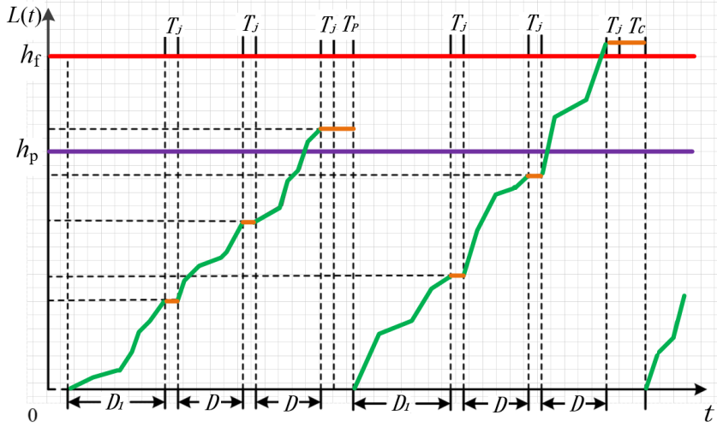
Figure 2. Schematic diagram of preventive inspection strategy for degrading system.
In Figure 2, L(t) represents the degradation level of equipment at time t , h_{f} denotes the failure threshold of equipment, and h_{p} represents the threshold for PM. During equipment operation, its performance undergoes a natural attenuation process characterized by significant stochastic features. From a system perspective, performance attenuation can be regarded as a continuous accumulation of damage, and when this accumulation reaches a critical point, the system will fail.

Mathematical model

4.1. Performance degradation model of equipment
For systems with monotonically increasing degradation, this study employs the IG process for modeling. Within any time interval, if the system's degradation increment follows an IG distribution, its probability density function is given by:
$f(t;u,λ)=\sqrt{\frac{λ}{2πt^{3}}}\exp{(}-\frac{λ(t-u)^{2}}{2u^{2}t}), t>0, u>0,λ>0$
Here, u and λ are the mean parameter and shape parameter of the IG distribution, respectively. These two parameters define the distribution. The mean parameter u determines the central tendency of the distribution, while the shape parameter λ controls the skewness and tail thickness of the distribution. As λ approaches infinity, the IG distribution gradually approximates the normal distribution, demonstrating the flexibility of parameter adjustment.
The mean of the IG distribution is given by $E(t)=u$, and the calculation of $E(t^{2})$ is shown in formula (2):
$E(t^{2})=\int_{0}^{∞}{t^{2}}\sqrt{\frac{λ}{2πt^{3}}}\exp{(}-\frac{λ(t-u)^{2}}{2u^{2}t})dt=\frac{u^{3}}{λ}+u^{2}$ (2)
The variance of the the IG distribution can be expressed by formula (3):
$D(t)=E(t^{2})-{\left[E(t)\right]}^{2}=\frac{u^{3}}{λ}$ (3)
The skewness of IG distribution can be calculated using the third central moment, as shown in formula (4):
$E(t-u)^{3}=\int_{0}^{∞}{(t-u)^{3}}\sqrt{\frac{λ}{2πt^{3}}}\exp{(}-\frac{λ(t-u)^{2}}{2u^{2}t})dt=3\sqrt{\frac{u}{λ}}$ (4)
The kurtosis of IG distribution can be calculated using the fourth central moment, as shown in formula (5):
$E\left(t-u)^{4}=\int_{0}^{∞}{(t-u)^{4}}\sqrt{\frac{λ}{2πt^{3}}}\exp{(}-\frac{λ(t-u)^{2}}{2u^{2}t}\right)dt=3+15\frac{u}{λ}$(5)
For an IG random process {L(t), t ≥0}, L(0)=0 and L(t) has independent increments; for all t≥0 and $Δ$t>0, L(t+$Δ$t)-L(t)~IG(u, λ). The cumulative distribution function of the IG distribution is:
$F(t;u,λ)=Φ(\sqrt{\frac{λ}{t}}(\frac{t}{u}-1))+\exp{(}\frac{2λ}{u})Φ(\sqrt{\frac{λ}{t}}(\frac{t}{u}+1))$(6)
Where $Φ$ is the standard normal distribution's cumulative distribution function, that is:
$Φ(z)=\frac{1}{\sqrt{2π}}\int_{-∞}^{z}{e^{-\frac{t^{2}}{2}}}dt$ (7)

4.2. Probability model for perfect preventive maintenance
Denote the probability of performing perfect PM at the k-th inspection as $θ_{k}$. At the first inspection, if h_{p}<L(t)<h_{f} , perfect PM will be performed with probability p. Therefore, the probability of performing perfect PM at the first inspection is:
$θ_{1}=prob\{h_{p}<L(D_{1})<h_{f}\}⋅p$ (8)
When analyzing the probability of successful PM at the second inspection, it is necessary to consider the outcome of the first inspection. Specifically, there are two scenarios: Scenario 1 is that no PM is required at the first inspection, but PM is needed and successfully implemented at the second inspection; Scenario 2 is that PM is required at the first inspection, but not successfully implemented, the system does not fail between the two inspections, and PM is successfully carried out at the second inspection. The probability of Scenario 1 occurring is:
$prob_{S1}^{P2}=prob\{L(D_{1})<h_{p} ∩ h_{p}<L(D_{1}+D)<h_{f}\}⋅p$ (9)
The probability of Scenario 2 occurring can be expressed as:
$prob_{S2}^{P2}=prob\left\{h_{p}<L\left(D_{1}\right)<h_{f} ∩ h_{p}<L\left(D_{1}+D\right)<h_{f}\right\}⋅\left(1-p\right)p$(10)
The probability of successfully performing PM at the second inspection is:
$θ_{2}=prob_{S1}^{P2}+prob_{S2}^{P2}$ (11)
Extending the above conclusion to a more general scenario, the probability of successfully implementing PM during the k-th (k≥3) inspection can be expressed as:

$$θ_{k}=prob\left\{L\left(D_{1}+\left(k-2\right)D\right)<h_{p}∩h_{p}<L\left(D_{1}+\left(k-1\right)D\right)<h_{f}\right\}⋅p+\sum_{n=2}^{k-1}{prob\{L(D_{1}+(n-2)D)<h_{p}}∩h_{p}<L(D_{1}+(n-1)D)<h_{f}∩h_{p}<L(D_{1}+(k-1)D)<h_{f}\}⋅(1-p)^{k-n}p +prob\{h_{p}<L(D_{1})<h_{f}∩h_{p}<L(D_{1}+(k-1)D)<h_{f}\}⋅(1-p)^{k-1}p$$ | (12)
Among them:
$prob\{L(D_{1}+(k-2)D)<h_{p}∩h_{p}<L(D_{1}+(k-1)D)<h_{f}\}=\int_{0}^{h_{p}}{\begin{aligned}&f(t,u(D_{1}+(k-2)D),λ) \\ &⋅\int_{h_{p}-t}^{h_{f}-t}{f(v,D,λ)dv}\end{aligned}}dt$ (13)

Formula (13) is the probability that all (k-1) inspections did not reach the PM threshold, and the k-th inspection reached the threshold and successfully implemented PM.

$$prob\left\{L\left(D_{1}+\left(n-2\right)D\right)<h_{p}∩h_{p}<L\left(D_{1}+\left(n-1\right)D\right)<h_{f}∩h_{p}<L\left(D_{1}+\left(k-1\right)D\right)<h_{f}\right\}=\int_{0}^{h_{p}}{f(t,u(D_{1}+(n-2)D),λ)\int_{h_{p}-t}^{h_{f}-t}{f(v,uD,λ)}}⋅F(h_{f}-t-v,u(k-n)D,λ)dvdt$$ | (14)

Formula (14) is the probability that the (k-2)-th inspection did not reach the threshold, the (k-1)-th inspection reached the threshold but failed to implement PM, and the k-th inspection successfully implemented PM.

$prob\{h_{p}<L(D_{1})<h_{f}∩h_{p}<L(D_{1}+(k-1)D)<h_{f}\}=\int_{h_{p}}^{h_{f}}{f(t,uD_{1},λ)F(h_{f}-t;u(k-1)D,λ)dt}$ (15)

Formula (15) represents the probability of successful implementation of PM during the k-th inspection, where all (k-1) inspections have reached the threshold but failed to implement PM.

4.3. Probability model for corrective maintenance
Denote the probability of performing CM at the k-th inspection as $ψ_{k}$. The probability of performing CM during the first inspection is:
$ψ_{1}=prob\{L(D_{1})>h_{f}\}$ (16)
When analyzing the feasibility of implementing CM during the second inspection, the results of the first inspection must be taken into account. Based on this, the situation of adopting CM during the second inspection can be divided into two categories: firstly, the system was in a fault-free state during the first inspection, but by the second inspection, its accumulated degradation level had exceeded the preset fault threshold; Secondly, although the system showed signs of requiring PM during the initial inspection, the maintenance was not successfully implemented, resulting in degradation exceeding the fault threshold during the second inspection. For the first scenario, the probability of its occurrence can be calculated as follows:
$prob_{S1}^{C2}=prob\{L(D_{1})<h_{p} ∩ L(D_{1}+D)>h_{f}\}$ (17)
The probability of the occurrence of situation two can be expressed as:
$prob_{S2}^{C2}=prob\{h_{p}​<L(D_{1})<h_{f} ∩ L(D_{1}+D)>h_{f}\}×\left(1-p\right)$ (18)
The probability of performing CM during the second inspection is:
$ψ_{2}=prob_{S1}^{C2}+prob_{S2}^{C2}$ (19)
Extending the above conclusion to a more general scenario, the probability of implementing CM during the k-th (k≥3) inspection can be expressed as:
$ψ_{k}=prob\left\{L\left(D_{1}+\left(k-2\right)D\right)<h_{p}∩L\left(D_{1}+\left(k-1\right)D\right)>h_{f}\right\} +prob\{L(D_{1}+(k-3)D)<h_{p}∩h_{p}<L(D_{1}+(k-2)D)<h_{f}∩L(D_{1}+(k-1)D)>h_{f}\}⋅(1-p)$ $+\sum_{n=2}^{k-2}{prob\{L(D_{1}+(n-2)D)<h_{p}∩h_{p}<L(D_{1}+(n-1)D)<h_{f}}∩h_{p}<L\left(D_{1}+\left(k-2\right)D\right) <h_{f}∩L(D_{1}+(k-1)D)>h_{f}\}⋅(1-p)^{k-n} +prob\{h_{p}<L(D_{1})<h_{f}∩h_{p}<L(D_{1}+(k-2)D)<h_{f}∩L(D_{1}+(k-1)D)>h_{f}\}⋅(1-p)^{k-1}$ | (20)
Among them:
$$prob\left\{L\left(D_{1}+\left(k-2\right)D\right)<b_{p}∩L\left(D_{1}+\left(k-1\right)D\right)>b_{f}\right\} =\int_{0}^{h_{P}}{f(t,u(D_{1}+(k-2)D),λ)[1-F(h_{f}-t,uD,λ)]dt}$$ | (21)

Formula (21) represents the probability that the system is in a healthy state for all (k-1) inspections, but enters a faulty state during the k-th inspection, indicating the need for CM.

$$prob\left\{L\left(D_{1}+\left(k-3\right)D\right)<h_{p}∩h_{p}<L\left(T_{1}+\left(k-2\right)T\right)<h_{f}∩L\left(D_{1}+\left(k-1\right)D\right)>h_{f}\right\} =\int_{0}^{h_{p}}{f(t,u(D_{1}+(k-3)D),λ)\int_{h_{p}-t}^{h_{f}-t}{f(v,uD,λ)}}[1-F(h_{f}-t-v,uD,λ)]dvdt$$ | (22)

Formula (22) represents the probability that PM was required for the first time during the (k-1)-th inspection, but was not successfully implemented, resulting in the cumulative degradation of the system exceeding the fault threshold during the k-th inspection and requiring CM.

$prob\{L(D_{1}+(n-2)D)<h_{p}∩h_{p}<L(D_{1}+(n-1)D)<h_{f}∩h_{p}<L\left(D_{1}+\left(k-2\right)D\right) ​​​​​​​​​​<h_{f}∩L(D_{1}+(k-1)D)>h_{f}\}=\int_{0}^{h_{p}}{f(t,u(D_{1}+(n-2)),λ)}\int_{h_{p}-t}^{h_{f}-t}{f(v,uD,λ)}×$ $\int_{0}^{h_{f}-t-v}{f(w,u((k}-n-1)D),λ)[1-F(h_{f}-t-v-w,uD,λ)]dwdvdt$ | (23)

Formula (23) represents the probability that PM was attempted but unsuccessful in all (k-1) inspections, and the cumulative degradation exceeded the fault threshold in the k-th test, requiring CM.

4.4. Expected warranty cost and availability model for equipment
The availability of the equipment is:
$A=\frac{T_{\text{work}}}{(T_{\text{work}}+T_{\text{halt}})}$ (24)
The expected working time of the equipment is:
$E(T_{\text{work}})=\sum_{k=1}^{λ}{(D_{1}+(k-1)D)×θ_{k}}+\sum_{k=1}^{λ}{(D_{1}+(k-1)D)×ψ_{k}}$ (25)
In the formula (25), the number of inspections is represented by $λ$, and the expression for $λ$ is:
$λ=1+\left\lfloor \frac{W-D_{1}-T_{j}}{D+T_{j}}\right\rfloor ,D_{1}<W$ (26)
In the formula (26), the symbol "⌊⌋" represents the floor function, which means taking the greatest integer less than or equal to the given number.
The expected downtime of the equipment is:
$E(T_{\text{halt}})=\sum_{k=1}^{λ}{E_{c,k}(T_{\text{halt}})}+\sum_{k=1}^{λ}{E_{p,k}(T_{\text{halt}})}$ (27)
The expressions for $E_{p,k}(T_{\text{halt}})$ and $E_{c,k}(T_{\text{halt}})$ are as follows:

$E_{p,k}\left(T_{\text{halt}}\right)=\left\{\begin{aligned}&(T_{j}+T_{p})⋅θ_{1}​​​​​​​​​​​​​​​​​​​​​​​​​​​​​​​k=1 \\ &(2T_{j}+T_{p})⋅θ_{2}​​​​​​​​​​​​​​​​​​​​​​​k=2 \\ &(kT_{j}+T_{p})⋅θ_{k}​​​​​​​​​​​​​​​​​​​​​​2<​​k≤λ\end{aligned}\right.{ E}_{c,k}(T_{\text{halt}})=\left\{\begin{aligned}&(T_{j}+T_{c})⋅ψ_{1}​​​​​​​​​​​​​​​​​​​​​​​​​​​​​​k=1 \\ &(2T_{j}+T_{c})⋅ψ_{2}​​​​​​​​​​​​​​​​​​​​​​k=2 \\ &(3T_{j}+T_{c})⋅ψ_{3} k=3 \\ &(kT_{j}+T_{c})⋅ψ_{k}​​​​​​​​​​​​​​​​​​​​​​3<​​k≤λ\end{aligned}\right.$ (28)

The calculation method for expected warranty cost is similar to the derivation process of expected downtime; only the relevant symbols need to be replaced. Specifically, replace the inspection time T_{j} with the inspection cost C_{j} , and replace the average time for each PM T_{p} and CM T_{c} with the corresponding average costs C_{p} and C_{c}. Based on this, the expression for warranty cost is:
$EC=\sum_{k=1}^{λ}{E_{c,k}(C)}+\sum_{k=1}^{λ}{E_{p,k}(C)}$ (29)

4.5. Performance warranty decision optimization model
When system availability is used as the core performance evaluation indicator, the relationship between the manufacturer's additional profit and system availability can be quantitatively described by a linear revenue function. The mathematical expression of this function is:
$EI=\left\{\begin{matrix}0, \\ ω+ϖ(A-A_{min}\end{matrix}\{\begin{matrix}A<A_{min} \\ A≥A_{min}\end{matrix}\right.$ (30)
In the formula (30), $ω$represents the fixed revenue from the performance warranty, and $ϖ$ (A-Amin) represents the additional reward revenue based on the performance results. If A < Amin, the manufacturer will not receive any additional revenue; if A≥Amin, the manufacturer will receive both the fixed revenue and the reward revenue. The performance warranty decision optimization model, which aims to maximize the manufacturer's warranty profit, can be expressed as:
$$\max{E}P(D_{1},D,h_{p})=EI-EC \\ (D_{1}*,D*,h_{p}*)=\operatorname{argmax}{E}P \\ s.t.​​​​\left\{\begin{aligned}&​0<D<D_{1}<D_{max} \\ &0<h_{p}<h_{f}\end{aligned}\right.$$ | (31)
By solving the optimization model in formula (31), the optimal first inspection interval, subsequent inspection intervals, and the PM threshold can be determined, along with the corresponding maximum manufacturer warranty profit. The market demand function for the product can be expressed as:
$R(W,h_{p},S_{p})=ϑ_{1}{S_{p}}^{-ξ_{1}}(ϑ_{2}+W)^{ξ_{2}}(1+ϑ_{3}\frac{b_{f}-b_{p}}{b_{f}})^{ξ_{3}}$ (32)
In the formula (32), $ϑ_{1}$ and $ϑ_{3}$ are amplitude factors, and $ϑ_{2}$ is a constant. $ξ_{1}$, $ξ_{2}$ and $ξ_{3}$ are elasticity coefficients. For the manufacturer, the sales profit of the product is given by:

$G\left(W,h_{p},S_{p}\right)=R\left(W,h_{p},S_{p}\right)⋅\left(S_{p}-Cs-EC\right) =[ϑ_{1}{S_{p}}^{-ξ_{1}}(ϑ_{2}+W)^{ξ_{2}}(1+ϑ_{3}\frac{h_{f}-h_{p}}{h_{f}})^{ξ_{3}}]⋅(S_{p}-Cs-EC)$ (33)

In formula (33), Cs represents the production cost.
Proposition 1: Let W≥0, hp≤hf, then the product price that maximizes the product sales profit is given by:
$S_{p}^{*}=\frac{ξ^{1}}{ξ^{1}-1}(Cs+EC)$ (34)
Proof: By taking the derivative of $G(W,h_{p},S_{p})$ with respect to Sp, the first-order derivative is given by:

$\frac{dG(W,h_{p},S_{p})}{dS_{p}}=[ϑ_{1}{S_{p}}^{-ξ_{1}-1}(ϑ_{2}+W)^{ξ_{2}}(1+ϑ_{3}\frac{h_{f}-h_{p}}{h_{f}})^{ξ_{3}}]×[S_{p}-ξ_{1}(S_{p}-Cs-EC)]$ (35)

Setting formula(35) equal to zero allows us to solve for formula (34). To further analyze the properties of right-hand side of formula (35) with respect to S_{p}, we can take the second derivative of $G(W,h_{p},S_{p})$ with respect to S_{p}. The specific steps are as follows:

$\frac{dG(W,h_{p},S_{p})}{dS_{p}^{2}}=[ϑ_{1}{S_{p}}^{-ξ_{1}-2}(ϑ_{2}+W)^{ξ_{2}}(1+ϑ_{3}\frac{h_{f}-h_{p}}{h_{f}})^{ξ_{3}}]×[(ξ_{1}+1)⋅(S_{p}-Cs-EC)-2S_{p}]$ (36)

Substituting formula (34) into formula (36), the resulting value of "$-(Cs+EC)$ " is strictly less than zero, which indicates that there is an optimal product price determined by formula (34) that maximizes the product sales profit. Based on this, the total profit of the manufacturer can be expressed as:
$G_{m}=G+EP⋅R$ (37)

Algorithm settings
The performance warranty decision model for the degrading system constructed in this paper aims to maximize the manufacturer's warranty profit by determining the optimal initial inspection interval, subsequent inspection intervals, and PM threshold. Due to the complexity of the mathematical expressions in the model, traditional numerical algorithms (such as grid search) are inefficient and lack sufficient accuracy when solving it. Therefore, this study employs an intelligent optimization algorithm to solve the model, thereby improving the computational efficiency and the accuracy of the results. The particle swarm optimization (PSO) algorithm, known for its fast convergence, few parameters, and simple implementation, is particularly effective for high-dimensional optimization problems and converges to the optimal solution faster than genetic algorithms. The PSO algorithm has been widely applied in engineering design, machine learning, and other fields, providing a powerful tool for solving practical problems. The two key elements of the PSO algorithm are the particles' velocity and position. The velocity vector serves as a search directive, specifying the particle's direction and magnitude for the subsequent iteration. Concurrently, the position vector encodes a candidate solution to the underlying optimization problem.
Assuming in an M-dimensional search space, there are N particles, each representing a solution, then: Xim =(xi1, xi2 ,......, xim); The distance and direction the particle moves is Vim =(vi1, vi2 ,......,vim); The individual optimal solution is Pim,pbest =(Pi1, Pi2,......, Pim); The global optimal solution is Pm, gbest =(P1, gbest , P2, gbest ,......, Pm, gbest); The individual historical optimal fitness value is fp; The swarm historical optimal fitness value is fg..
The updated velocity is given by the expression below.
$v_{im}^{y+1}=wv_{im}^{y}+c_{1}r_{1}(p_{im,pbest}^{y}-x_{im}^{y})+c_{2}r_{2}\left(p_{m,gbest}^{y}-x_{im}^{y}\right)$ (38)
The particle position is updated as follows:
$x_{im}^{y+1}=x_{im}^{y}+v_{im}^{y+1}$ (39)
In the formulas, y represents the iteration number, and w is the inertia weight. C1 is the individual learning factor, and C2 is the group learning factor. r1 and r2 are random numbers in the interval [0, 1] that introduce randomness to the search process. $v_{im}^{y}$ is the velocity vector of the m-th dimension for particle i during the y-th iteration. $x_{im}^{y}$ is the position vector of the m-th dimension for particle i during the y-th iteration. After y iterations, the historical best position for the m-th dimension is recorded at two levels: the individual best $p_{im,pbest}^{y}$ (found by particle i) and the global best $p_{m,gbest}^{y}$ (found by the entire swarm). The significant and hard-to-control influence of particle initial values is a key factor in shaping the PSO algorithm's optimization outcomes. Random initialization can lead to inconsistent results across multiple runs, failing to reliably converge to an optimum and potentially yielding invalid solutions. Hence, particle initialization is a critical step, as it effectively determines the initial search trajectory and thereby influences the entire process's convergence speed and direction.
Given that the independent variables in this study are the initial preventive inspection interval D1, the subsequent preventive inspection interval D, and the PM threshold hp, the dimension of the particles (number of independent variables) is set to M=3. The remaining parameter settings are as follows: iteration y=80, population size N=100, inertia weight w=1.1, learning factors C1=1.6 and C2=1.8.
Figure 3 shows the solving process of the PSO algorithm.
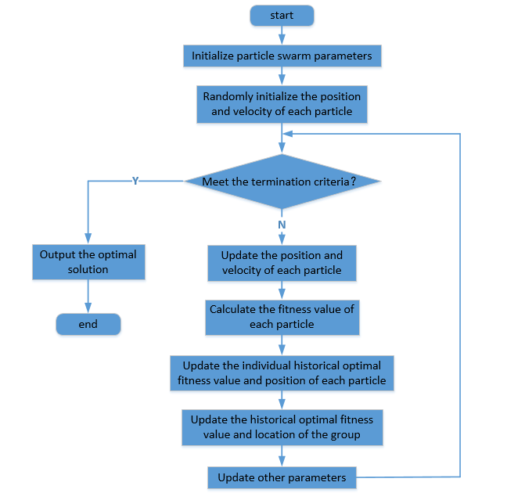
Figure 3. Flowchart of PSO Algorithm Solution.
Based on this, we can calculate the manufacturer's maximum warranty profit (EP) and the corresponding optimal decision variable combination (D1, D, hp) using a MATLAB program. Additionally, using the performance warranty decision model, we can further determine the manufacturer's warranty cost (EC) and manufacturer's total profit (Gm).

Case validation and result analysis
This section takes a large construction machinery fuel engine as the research object, and uses the PSO algorithm to solve the PWS optimization model constructed, obtaining the optimal PWS implementation plan. By comparing and analyzing the PWS with the minimum warranty cost strategy and the fixed-cycle inspection strategy, it was found that the PWS enables manufacturers to achieve higher warranty profits, thereby verifying the superiority of the strategy proposed in this article. In addition, to further explore the sensitivity of model parameters, this section systematically analyzed the impact of key parameter changes on the manufacturer's optimal performance warranty profit.

6.1. Optimal performance warranty strategy and comparative analysis
Considering that the degradation process of a large fuel engine follows the IG distribution law, as a core component in engineering machinery systems, its maintenance cost and time investment are significantly higher than those of other ordinary components. To ensure the reliable operation of equipment, it is necessary to systematically monitor and assess its degradation. The time is measured by month, and the cost is measured by 10⁴ RMB. The performance warranty period of this component is W=72, the mean parameter of the IG degradation process is u=1.6, the shape parameter is λ=0.8, and the probability of perfect PM is p=0.9. The average time for each PM is T_{p}=2.1, and the average cost for each PM is C_{p}=40. The average time per repair is T_{c}=5.5, and the cost per repair is C_{c}=190. The single inspection time is T_{j} =0.25, the single inspection cost is C_{j} =3.2, the fixed income is $ϖ$ =2, the reward income coefficient is $ϖ$ =21, and the minimum acceptable usability for users is A_{min}=0.7. In the parameters of the product demand function,$ϑ_{1}=8×10^{9}$, $ϑ_{2}=0.6$, $ϑ_{3}=0.02$, $ξ_{1}=1.69$, $ξ_{2}=0.2$, $ξ_{3}=0.03$, $Cs=585$.
By incorporating the above parameters into the model and solving it using the PSO algorithm, the optimal warranty plan for PWS is obtained as follows: D₁=19.32, D=3.98, h_{p}=38.01. At this point, the maximum performance warranty profit for the manufacturer is EP=3.95, and warranty cost can be further calculated as EC=2.30, with the total profit for the manufacturer being G_{m}=3.75×10⁷. When h_{p}=38.01, the changes in the manufacturer's performance warranty profit, performance warranty cost, and total profit with respect to D₁ and D are shown in Figures 4-6, respectively.
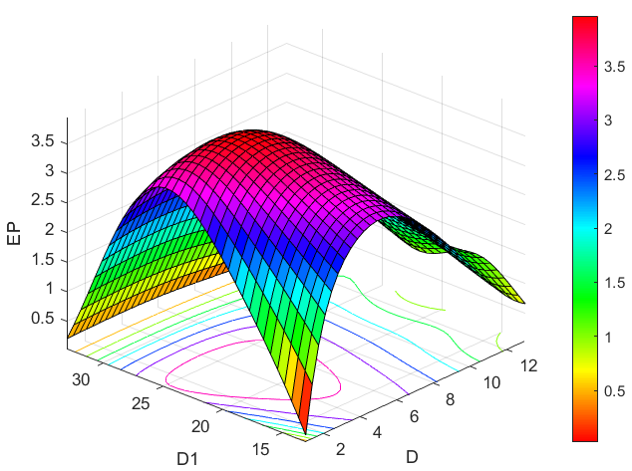
Figure 4. The relationship between performance warranty profit and changes in D₁ and D.
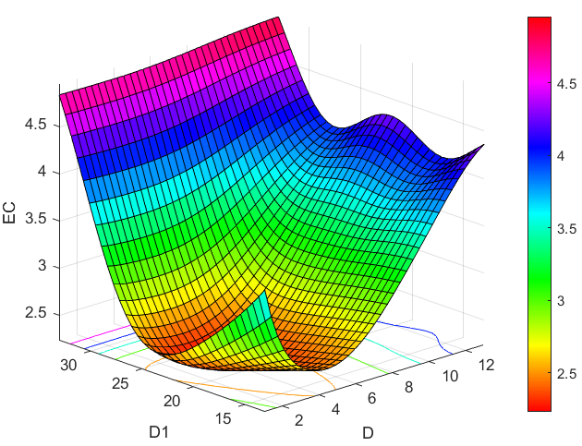
Figure 5. The relationship between performance warranty cost and changes in D₁ and D.
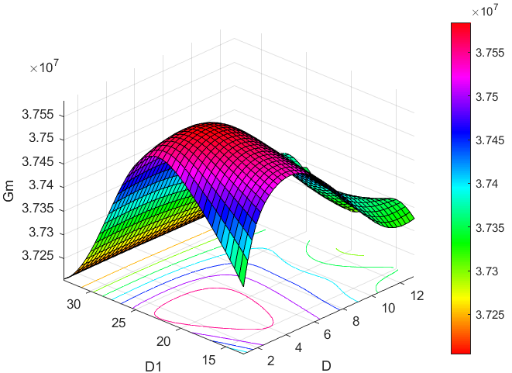
Figure 6. The relationship between manufacturer's total profit and changes in D1 and D.
The PWS proposed in this paper has achieved breakthroughs in the following two aspects: First, it incorporates an incentive mechanism based on equipment availability, constructing an optimization model to maximize the manufacturer's performance warranty profit. Second, it introduces the concept of differentiated preventive inspection intervals, that is, distinguishing between the initial inspection interval and subsequent inspection intervals. To verify the practical value of the above innovations, this section designs comparative experiments, comparing the PWS with two traditional strategies, Strategy A and Strategy B. The specific descriptions of Strategy A and Strategy B are as follows.
Strategy A: aims to minimize warranty costs and does not consider maximizing the manufacturer's performance warranty profit [26]. The corresponding optimization model is:
$$\min{E}C(D_{1},D,h_{p}) \\ (D_{1}*,D*,h_{p}*)=\operatorname{argmin}{\{}EC(D_{1},D,h_{p})\} \\ s.t.​​​​\left\{\begin{aligned}&​0<D<D_{1}<D_{max} \\ &0<h_{p}<h_{f}\end{aligned}\right.$$ | (40)
Compared with the PWS proposed in this paper, the condition-maintenance strategy based on minimum warranty cost differs only in its decision-making objective.
Strategy B: This strategy employs a fixed inspection interval without distinguishing between the initial inspection and subsequent inspections. In contrast, the PWS proposed in this paper innovatively adopts a differentiated inspection interval scheme, in which the initial inspection interval and subsequent inspection intervals are set to different time parameters. This differentiated periodic inspection mechanism has been successfully applied in the inspection practices of multiple mechanical systems [27]. To further explore the necessity of differentiated inspection intervals, this strategy sets D₁=D, thereby enabling a comparative analysis of unified and differentiated inspection intervals.
The process of solving the maximum warranty profit for the manufacturer under different warranty strategies is shown in Figure 7.
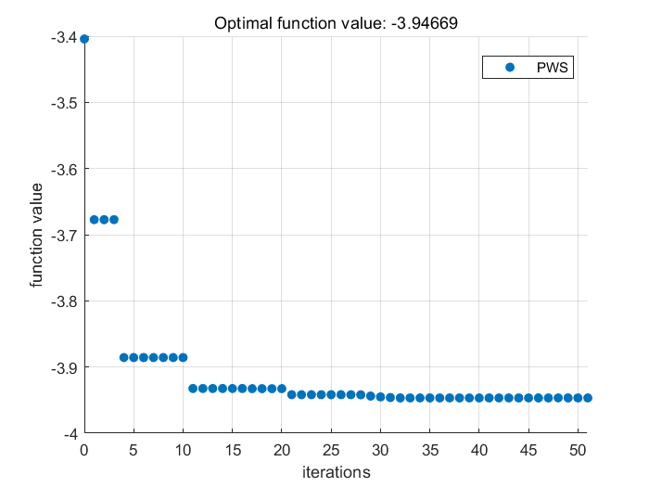
(a) The maximum warranty profit of the manufacturer under PWS.
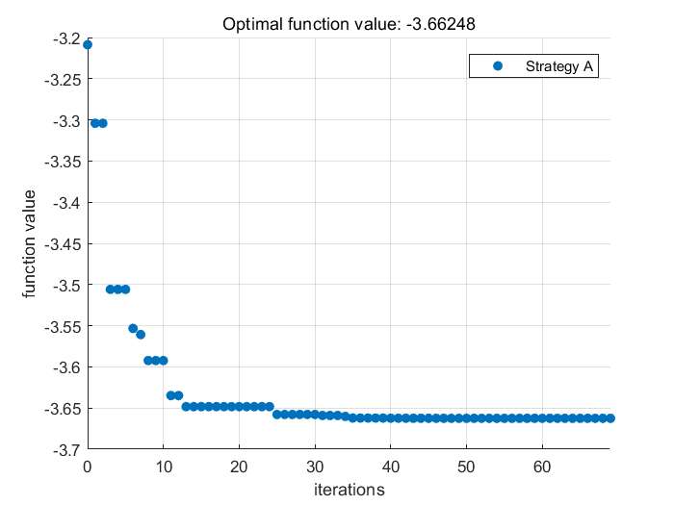
(b) The maximum warranty profit of the manufacturer under Strategy A.
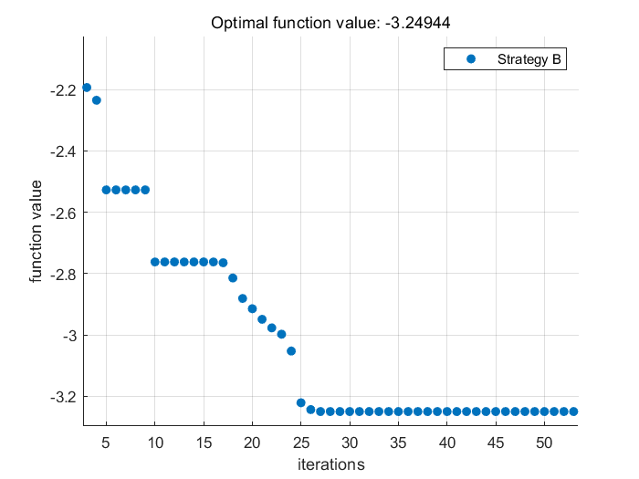
(c) The maximum warranty profit of the manufacturer under Strategy B.
Figure 7. The maximum warranty profit corresponding to different warranty strategies.
Table 2. Optimal warranty plans under different warranty strategies.
 | D₁ | D | h_{p} | EP | EC | G_{m}
PWS | 19.32 | 3.98 | 38.01 | 3.95 | 2.30 | 3.757×10⁷
Strategy A | 18.15 | 3.51 | 38.97 | 3.66 | 2.19 | 3.690×10⁷
Strategy B | 10.64 | 10.64 | 27.93 | 3.25 | 2.71 | 3.321×10⁷
According to the comparative analysis results in Table 2, the PWS proposed in this study performs best among the three strategies. Strategy B performs the worst, mainly because of lower failure rates in the early stages of equipment operation. By implementing a differentiated inspection interval settings, that is, extending the initial inspection interval and shortening the subsequent inspection intervals, it is possible to better align with the objective laws of equipment degradation. Strategy B has obvious shortcomings in practical applications: it is prone to over-inspection in the early stages of equipment operation, leading to increased inspection costs, and may result in insufficient inspection in the equipment aging phase, increasing the risk of failures. These dual negative impacts not only increase warranty costs but also reduce the warranty profit margins. More seriously, the increase in warranty costs will directly lead to higher product prices, which in turn affects market demand and ultimately compresses the manufacturer's overall profit margins. Therefore, implementing a differentiated inspection interval strategy has significant practical significance.
Compared with the PWS, the performance of Strategy A is not satisfactory, which can be reasonably explained by the decision-making results. The data in Table 2 show that, to minimize warranty costs, Strategy A must adopt a higher inspection frequency. Although this high-frequency inspection strategy can effectively reduce the probability of post-failure repairs, frequent inspection downtimes significantly reduce equipment availability and directly affect the manufacturer's performance warranty profit through the reward-and-punishment incentive mechanism. In terms of revenue indicators, Strategy A performs worse than the PWS in both the manufacturer's warranty profit and total profit. This comparative result clearly shows that, in formulating warranty strategies, if manufacturers solely pursue reducing warranty costs, they will not only fail to expand their profit margins but may even have the opposite effect in some cases.

6.2. Sensitivity analysis

6.2.1. Impact analysis of IG degradation process parameters
The mean parameter u and the shape parameter λ of the IG process can significantly affect the degradation process of the equipment state. From formulas (3), (4), and (5), it is known that the larger the value of u, the greater the variance, skewness, and kurtosis of the IG distribution of the equipment state degradation, which in turn leads to an accelerated degradation rate of the equipment state. Conversely, the larger the value of λ, the smaller the variance, skewness, and kurtosis of the IG distribution of the equipment state degradation, which, in turn, slows down the degradation rate of the equipment state. To explore the impact of the IG degradation process parameters on the optimal warranty plan, this study sets parameter variation ranges as follows: u increases from 1.5 to 1.7 with an increment of 0.1; λ increases from 0.6 to 1.0 with an increment of 0.1. The specific calculation results for the optimal warranty plan under each parameter combination are detailed in Table 3.
The maximum warranty profit of the manufacturer formed under different degradation process parameter combinations is shown in Figure 8.

Table 3. Optimal warranty plans corresponding to IG degradation process parameters.
$$u=1.5$$ | PWS |  |  |  | Strategy A |  |  |  | Strategy B
$$λ$$ | D₁ | D |  | h_{p} | D₁ | D | h_{p} |  | D₁ | D | h_{p}
0.6 | 11.44 | 13.33 |  | 30.12 | 15.85 | 5.00 | 39.74 |  | 9.23 | 9.23 | 30.55
0.7 | 19.21 | 4.95 |  | 38.66 | 18.72 | 4.61 | 39.47 |  | 10.73 | 10.73 | 29.97
0.8 | 19.84 | 4.23 |  | 38.20 | 19.36 | 4.05 | 38.01 |  | 11.56 | 11.56 | 27.87
0.9 | 23.02 | 3.88 |  | 35.31 | 22.18 | 3.84 | 37.04 |  | 10.52 | 10.52 | 26.38
1.0 | 26.64 | 1.60 |  | 13.35 | 25.29 | 3.45 | 36.72 |  | 10.10 | 10.10 | 27.89
$$u=1.6$$ | PWS |  |  |  | Strategy A |  |  |  | Strategy B
$$λ$$ | D₁ | D |  | h_{p} | D₁ | D | h_{p} |  | D₁ | D | h_{p}
0.6 | 11.35 | 10.30 |  | 31.35 | 14.03 | 5.10 | 37.98 |  | 9.61 | 9.61 | 29.55
0.7 | 16.11 | 5.86 |  | 38.04 | 15.92 | 3.92 | 37.96 |  | 10.87 | 10.87 | 30.97
0.8 | 19.32 | 3.98 |  | 38.01 | 18.15 | 3.51 | 38.97 |  | 10.64 | 10.64 | 27.93
0.9 | 19.88 | 3.73 |  | 35.68 | 21.95 | 2.88 | 37.20 |  | 9.07 | 9.07 | 26.38
1.0 | 22.79 | 1.61 |  | 12.29 | 24.78 | 1.62 | 17.77 |  | 7.43 | 7.43 | 30.51
$$u=1.7$$ | PWS |  |  |  | Strategy A |  |  |  | Strategy B
$$λ$$ | D₁ | D |  | h_{p} | D₁ | D | h_{p} |  | D₁ | D | h_{p}
0.6 | 12.58 | 5.56 |  | 38.77 | 12.20 | 4.59 | 39.22 |  | 9.81 | 9.81 | 29.33
0.7 | 15.32 | 4.25 |  | 36.54 | 16.13 | 4.00 | 37.15 |  | 9.89 | 9.89 | 27.97
0.8 | 20.06 | 4.01 |  | 36.39 | 17.99 | 3.37 | 36.34 |  | 10.43 | 10.43 | 27.85
0.9 | 21.44 | 1.62 |  | 16.98 | 19.08 | 2.93 | 35.87 |  | 9.97 | 9.97 | 26.38
1.0 | 23.10 | 1.63 |  | 11.21 | 21.22 | 1.66 | 11.29 |  | 7.29 | 7.29 | 29.51
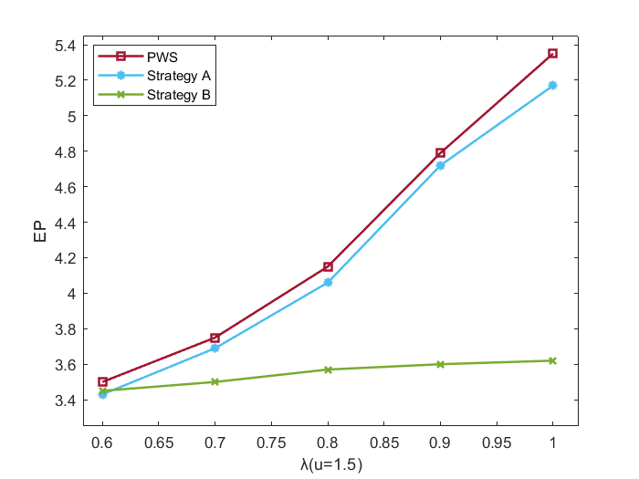 |  |  | 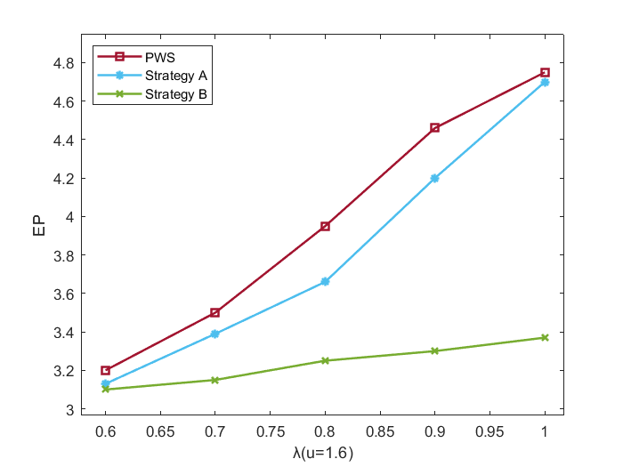 |  |  |  |  | 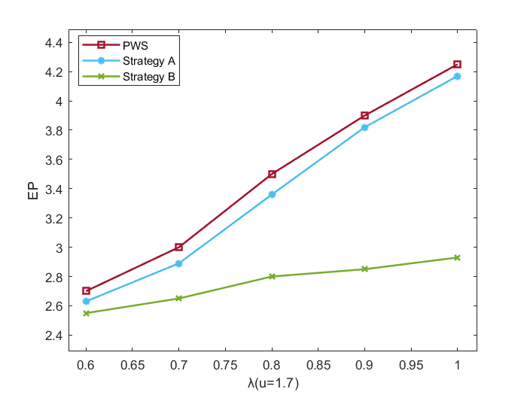
(a) when u=1.5, the maximum warranty profit changes with λ. |  |  | (b) when u=1.6, the maximum warranty profit changes with λ. |  |  |  |  | (c) when u=1.7, the maximum warranty profit changes with λ.
Figure 8. The relationship between the maximum warranty profit and the parameters of the IG process.

(i) The analysis in Figure 8 displays that within different values for parameters of the IG degradation process, the PWS always maintains the best performance. This phenomenon fully confirms that the PWS proposed in this paper has broad applicability and can effectively adapt to IG degradation systems with different degradation rates.
(ii) All three warranty strategies exhibit the same response pattern to changes in the parameters of the IG degradation process: When the mean parameter u is held constant, the manufacturer's warranty profit increases as the shape parameter λ increases; conversely, when λ is fixed, the manufacturer's warranty profit decreases as the mean parameter u increases. The underlying mechanism for this pattern is as follows: When u is constant, an increase in λ leads to a slower degradation rate, thereby reducing the probability of failure and ultimately increasing the manufacturer's warranty profit. Correspondingly, when λ is held constant, an increase in u accelerates the system's degradation rate, increasing the likelihood of failure and thus decreasing the manufacturer's warranty profit.

6.2.2. Impact analysis of preventive maintenance threshold h_{p}
This section mainly investigates the impact of h_{p} on the manufacturer's performance warranty profit. The h_{p} values are set to 20, 35, and 50, respectively, with all other parameters consistent with those in Section 7.1. The changes in the manufacturer's performance warranty profit with D₁ and D under different values of h_{p} are displayed in Figure 10.
(i) Figure 10 shows the case when the values of D₁ and D are small, a lower value of h_{p} is conducive to increasing the manufacturer's performance warranty profit, with the maximum performance warranty profit corresponding to h_{p}=20. When the values of D₁ and D are large, a moderate value of h_{p} is beneficial for increasing the manufacturer's performance warranty profit, with the maximum performance warranty profit corresponding to h_{p}=35.
(ii) From Figure 10, it can be observed that when the value of h_{p} is 50, the corresponding manufacturer's performance warranty profit is significantly lower than when h_{p} is 20 or 35. This indicates that the value of h_{p} should not be too large; otherwise, it will increase the equipment's failure rate, resulting in longer downtime and higher CM costs, thereby causing
a noticeable "plunge" in the manufacturer's performance warranty profit.
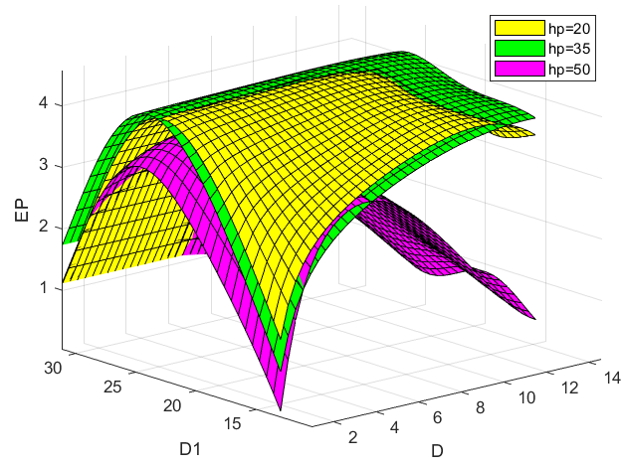
Figure 10. The maximum warranty profit of the manufacturer changes with h_{p}.

Conclusion
In the performance warranty mode, users do not need to limit the manufacturer's specific operating procedures, but only need to set clear performance goals and corresponding incentive policies, in order to encourage manufacturers to independently optimize the quality standards, technical performance, and maintenance efficiency of equipment. This article takes the IG degradation system as the research object and innovatively proposes a PWS. Its core contribution lies in incorporating
a preventive inspection mechanism into the PWS and differentiating the time interval between the initial and subsequent inspections. In addition, this study constructs
a linear profit function with system availability as the sole assessment indicator, directly linking the manufacturer's warranty profit to equipment availability, thereby stimulating the manufacturer's technological innovation. Finally, this article validates the effectiveness of the strategy through case studies and conducts sensitivity analysis, further revealing the optimization space for key parameters. The research results show that: (1) Compared with the CBM strategy based on minimizing warranty cost and the warranty strategy that does not differentiate between the initial and subsequent inspection intervals, the proposed PWS increases the manufacturer's warranty profit by 7.9% and 21.5%, respectively, demonstrating the effectiveness of the strategy. (2) The parameters of the IG degradation process have a significant impact on the warranty plan and the manufacturer's warranty profit. For example, when the mean parameter remains constant, a 1% increase in the shape parameter leads to a 0.82% increase in the manufacturer's warranty profit. Manufacturers should focus on the system's degradation characteristics to formulate scientifically and rationally designed warranty plans. (3) The values of the initial inspection interval, subsequent inspection interval, and PM threshold should be moderate, neither too large nor too small. In particular, the PM threshold should not be set too high, as this can increase the equipment's failure rate and cause a "plunge" in the manufacturer's warranty profit. Manufacturers should avoid empiricism and use quantitative methods to determine scientifically and rationally appropriate inspection intervals and PM thresholds.
There are several expandable research directions in this study. Firstly, the current model is designed for single-component systems and can be expanded to multi-component systems in the future, with a focus on examining the impact of failure correlation between components on warranty strategies. Secondly, further differentiating the interval between subsequent tests will be a meaningful research topic. Thirdly, developing more efficient intelligent solving algorithms is also a future research direction.

References
- Dong E, Cheng Z, Liu Z, Zhu X, Wang R, Bai Y. Optimization model for performance-based warranty decision of degraded systems based on improved sparrow search algorithm. Journal of Systems Engineering and Electronics, 2025, 36(5): 1259-1280. https://doi: 10.23919/JSEE.2025.000135.
- Wang X, Liu B, Zhao X. A performance-based warranty for products subject to competing hard and soft failures. International Journal of Production Economics 2021; 233: 107974. https://doi.org/10.1016/j.ijpe.2020.107974.
- Gao X, Cheng Z, Gao T, Wang R, Jiang K, Dong E. The optimal joint preventive maintenance strategy for the equipment under two-dimensional extended warranty. Eksploatacja i Niezawodność-Maintenance and Reliability 2025; 27(4): 203763. https://doi.org/10.17531/ein/203763.
- Tan S, Hu Q, Guo C, Zhu D, Dong E, Zhang F. Operational readiness-oriented condition-based maintenance and spare parts optimization for multi-state systems. Reliability Engineering and System Safety 2025; 264: 111367. https://doi.org/10.1016/j.ress.2025.111367.
- Kang J, Wang Z, Soares C G. Condition-Based Maintenance for Offshore Wind Turbines Based on Support Vector Machine. Energies 2020; 13(14): 3518. https://doi.org/10.3390/en13143518.
- Dong E, Cheng Z, Liu Z, Zhu X, Wang R, Bai Y. Optimization model for performance-based warranty decision of degraded systems based on improved sparrow search algorithm. Journal of Systems Engineering and Electronics 2025; 36(5): 1259–1280. https://doi.org/10.23919/JSEE.2025.000135.
- Hypko P, Tilebein M, Gleich R. Clarifying the concept of performance-based contracting in manufacturing industries. Journal of Service Management 2010; 21(5): 625–655. https://doi.org/10.1108/09564231011079075.
- Randall W S, Pohlen T L, Hanna J B. Evolving a theory of performance‐based logistics using insights from service dominant logic. Journal of Business Logistics 2010; 31(2): 35–61. https://doi.org/10.1002/j.2158-1592.2010.tb00142.x.
- Tan, B. Design of balanced energy savings performance contracts. International Journal of Production Research 2019; 58(5): 1401–1424. https://doi.org/10.1080/00207543.2019.1641240.
- Akkermans H, van Oppen W, Wynstra F, Voss C. Contracting outsourced services with collaborative key performance indicators. Journal of Operations Management 2019; 65(1): 22–47. https://doi.org/10.1002/joom.1002.
- Selviaridis K, van der Valk W. Framing contractual performance incentives: effects on supplier behaviour. International Journal of Operations &amp; Production Management 2019; 39(2): 190–213. https://doi.org/10.1108/ijopm-10-2017-0586.
- Batista L, Davis-Poynter S, Ng I, Maull R. Servitization through outcome-based contract – A systems perspective from the defence industry. International Journal of Production Economics 2017; 192: 133–143. https://doi.org/10.1016/j.ijpe.2016.12.005.
- Guajardo J A, Cohen M A, Kim S H, Netessine S. Impact of Performance-Based Contracting on Product Reliability: An Empirical Analysis. SSRN Electronic Journal 2011; https://doi.org/10.2139/ssrn.1807049.
- Hypko P, Tilebein M, Gleich R. Benefits and uncertainties of performance‐based contracting in manufacturing industries. Journal of Service Management 2010; 21(4): 460–489. https://doi.org/10.1108/09564231011066114.
- Schaefers T, Ruffer S, Böhm E. Outcome-based contracting from the customers’ perspective: A means-end chain analytical exploration. Industrial Marketing Management 2021; 93: 466–481. https://doi.org/10.1016/j.indmarman.2020.06.002.
- Korkeamäki L, Kohtamäki M, Parida V. Worth the risk? The profit impact of outcome-based service offerings for manufacturing firms. Journal of Business Research 2021; 131: 92–102. https://doi.org/10.1016/j.jbusres.2021.03.048.
- Shang T, Sun X, Liu P, Gao J. Cracking the Achilles’ heel of energy performance contracting projects: the credit risk identification method for clients. International Journal of Green Energy 2020; 17(3): 196–207. https://doi.org/10.1080/15435075.2020.1712213.
- Dai A, Wang X, Li Y, Li T, He S. Design of a performance-based warranty policy with replacement–repair strategy and cumulative cost threshold. International Journal of Production Economics 2023; 255: 108700. https://doi.org/10.1016/j.ijpe.2022.108700.
- Yang L, Ye Z, Lee C G, Yang S, Peng R. A two-phase preventive maintenance policy considering imperfect repair and postponed replacement. European Journal of Operational Research 2019; 274(3): 966–977. https://doi.org/10.1016/j.ejor.2018.10.049.
- Wang Y, Liu Y, Chen J, Li X. Reliability and condition-based maintenance modeling for systems operating under performance-based contracting. Computers and Industrial Engineering 2020; 142: 106344. https://doi.org/10.1016/j.cie.2020.106344.
- Li Z, Zi Y, Chen J, Pan J, Zhou Z. Performance-guided maintenance policy and optimization for transmission system of shipborne antenna with multiple components. Ocean Engineering 2020; 199: 106903. https://doi.org/10.1016/j.oceaneng.2019.106903.
- Hosseinifard Z, Shao L, Talluri S. Service-Level Agreement with Dynamic Inventory Policy: The Effect of the Performance Review Period and the Incentive Structure. Decision Sciences 2021; 53(5): 802–826. https://doi.org/10.1111/deci.12506.
- Patra P, Kumar U D, Nowicki D R, Randall W S. Effective management of performance-based contracts for sustainment dominant systems. International Journal of Production Economics 2019; 208: 369–382. https://doi.org/10.1016/j.ijpe.2018.11.025.
- Gao X, Dong E, Gao T, Jiang K, Zhu B, Wang Y, Cheng Z. Cost-availability ratio modeling of two-dimensional extended warranty for multi-component systems with fault correlation. International Journal of Industrial Engineering Computations 2026; 17: 265–282. https://doi: 10.5267/j.ijiec.2025.9.005.
- Gao X, Wen L, Dong E, Gao T, Jiang K, Zhu B, Wang Y, Cheng, Z. Modeling of warranty decisions based on optimal preventive replacement considering the structural correlation of multi-component parallel systems. AIP Advances 2025; 15(10). https://doi.org/10.1063/5.0300540.
- Huang Y, Fang C, Wijaya S. Condition-based preventive maintenance with a yield rate threshold for deteriorating repairable systems. Quality and Reliability Engineering International 2022; 38(8): 4122–4140. https://doi.org/10.1002/qre.3191.
- Golmohammadi E, Ardakan M A. Reliability optimization problem with the mixed strategy, degrading components, and a periodic inspection and maintenance policy. Reliability Engineering and System Safety 2022; 223: 108500. https://doi.org/10.1016/j.ress.2022.108500.

